**Assignment 6 Session 1:**

Creating a database named ‘Custom’:



Using ‘custom’ database which we created

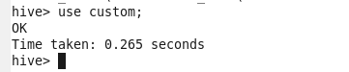

Creating a table named “temperature_data” inside ‘custom’ having below fields:

* 1. Date (mm-dd-yyyy) format
  2. Zip code
  3. Temperature

(This table will be loaded from comma-delimited file.)



Table “temperature_data” is created:

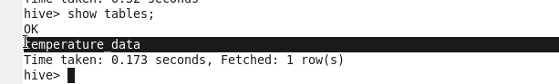

describing hive table;

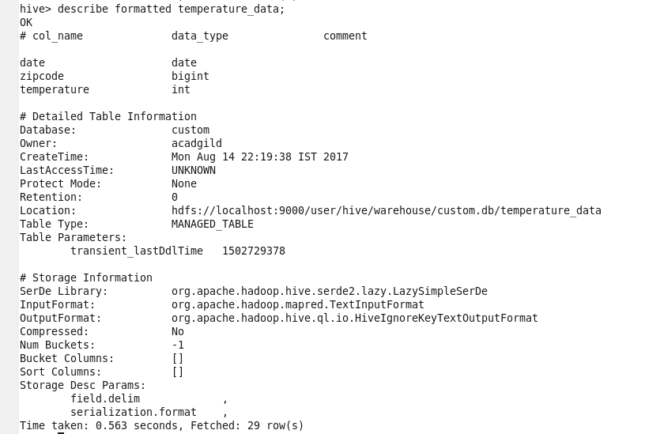

1. Load the dataset.txt (comma delimited) in to table.

dataset.txt file in hdfs location:

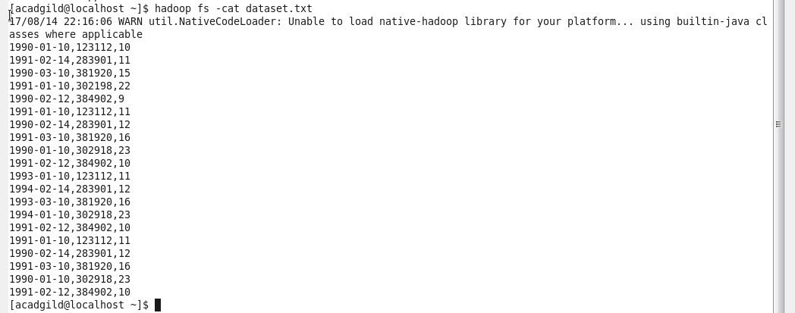

Loading **dataset.txt** file data in to “temperature_data” table:

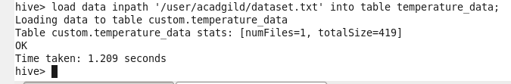

Data loaded successfully from dataset.txt file to temperature_data hive table.

